**Introduction of Project**

• Objective of the Project

• Scope of the Project

• Project Plan

• The Existing System

• Background of the Organization

• Current Problems

• Areas for Improvement

• Proposed System

• Input/Output Requirement

• Hardware and Software Requirement

• Database Requirement

• System Design

• Tables and Fields for Database

• Database Dictionary

• Server and Client Side technology

• Future Scope of the Project

• Conclusion

• Reference or Bibliography

­­­­



**COVInfo**

Introduction of Project

**The modern-day computer has become an important part of our daily life. Also, their usage has increased much fold during the last decade. Nowadays, they use the computer in every office whether private or government. Mankind is using computers for over many decades now. Also, they are used in many fields like agriculture, designing, machinery making, defense and many more. Above all, they have revolutionized the whole world. As the usage of computer increased it became a necessity for almost every field to use computers for their operations. Also, they have made working and sorting things easier. Below we are mentioning some of the important fields that use a computer in their daily operation** .Modern age is an age of computer. Computer has just become a part of our life. The computer education in India was started in somewhere in sixties. Now with the advent of microcomputer, it has become possible to have mass education in this field. The major advantage of computers is the speed which calculated are the and relative of output comes. Computer can store much information and solve our problem within very short duration. So keeping these things in views, I have computerized my small project work on “covid related information”

**COVInfo**

COVInfo is a software developed by the students of THE TONSBRIDGE SCHOOL to perform some specific tasks. During this pandemic we must have noticed wherever we go, our temperature, name, pulse rate and other details are noted. As per Covid protocol our school is also following the same. Keeping that in mind we came up with an idea of developing software for the same which can be used by the school to enter data such as temperature of the students with their name and class which would make it easier for the school to track the temperature of the students and to have safe schooling. The software offers the user to perform many tasks, some modules are listed below.

* To insert data
* To delete data
* To find data

To create an user friendly environment we have created homepage making it easier for the user to input data according to their need such as student corner to enter student data and same for teachers and visitors. This is a user-friendly software that allows user to edit, search, share data.

This particular software was developed using PYTHON and MYSQL database as a backend.

Objective

The objectives of the system are-

¬ To reduce paperwork.

¬ Reduced operational time.

¬ Increased accuracy and reliability.

¬ Increased operational efficiency.

¬ Data security.

This software package can be readily used by non-programming personal avoiding human handled chance of error. This project is used by two types of users

1. user
2. Builder

New features can be added as per requirements.

SCOPE

This project has a large scope as it has the following features which help in making it easy to use, understand and modify it:

¬ Easy to online drafting.

¬ No Need to do Paper Work.

¬ To save the environment by using paper free work.

¬ To increase the accuracy and efficiency to edit data

¬ Management of Data.

This website can be readily used by non-programming personal avoiding human handled chance of error. This project is used by two types of users

* User
* builder

Main Points are:-

• to easily enter data.

• finding data

•sharing data

• Selection Results



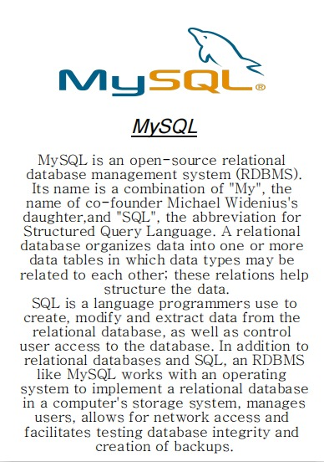

REFERENCES

•http://www.w3schools.com/php/

•[www.stackoverflow.com](http://www.stackoverflow.com)

* <http://php.net/manual/en/index.php>
* <http://dev.mysql.com/doc/refman/5.7/en/tutorial.htm>
* <http://www.tutorialspoint.com/mysql/>
* https://en.wikipedia.org/wiki/Real_estat